Database System Engineering and Distributed Backend Development
Course Code: 25CS13002E
ROLL NO:2520030177
NAME: P.HARINI
INSERT CUSTOMER DATA
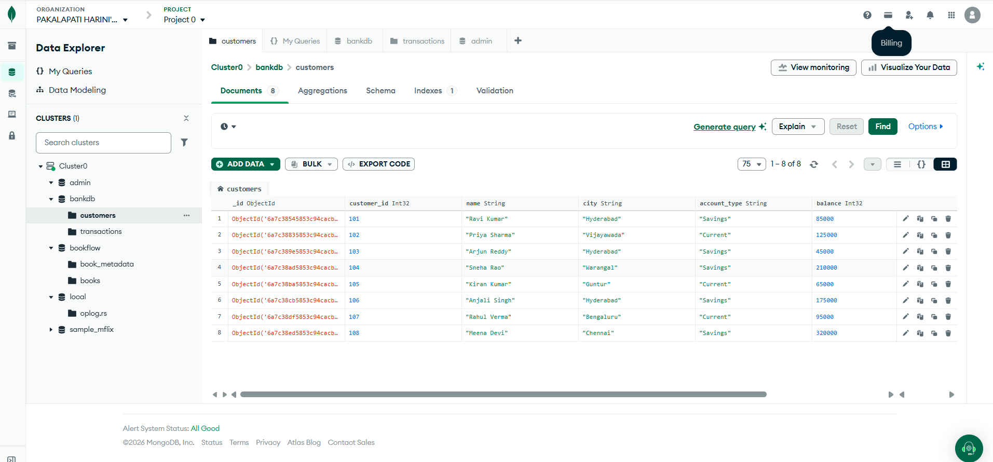
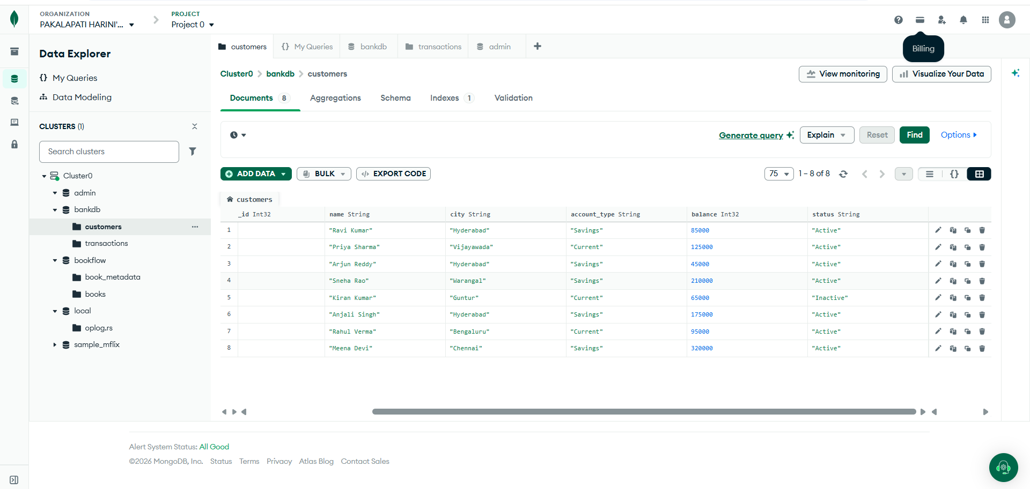

INSERT TRANSACTION DATA
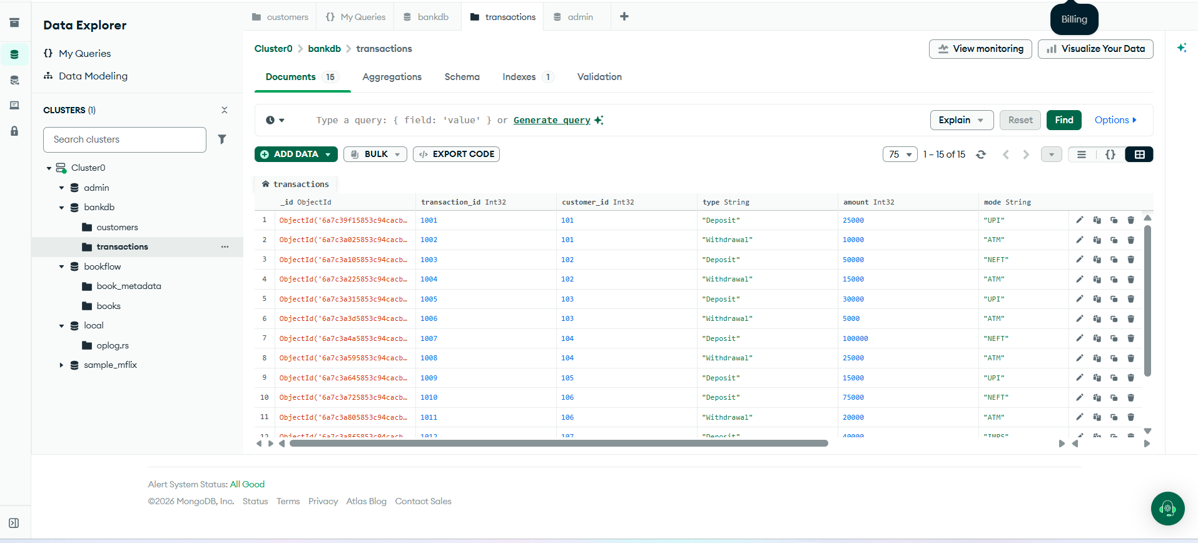
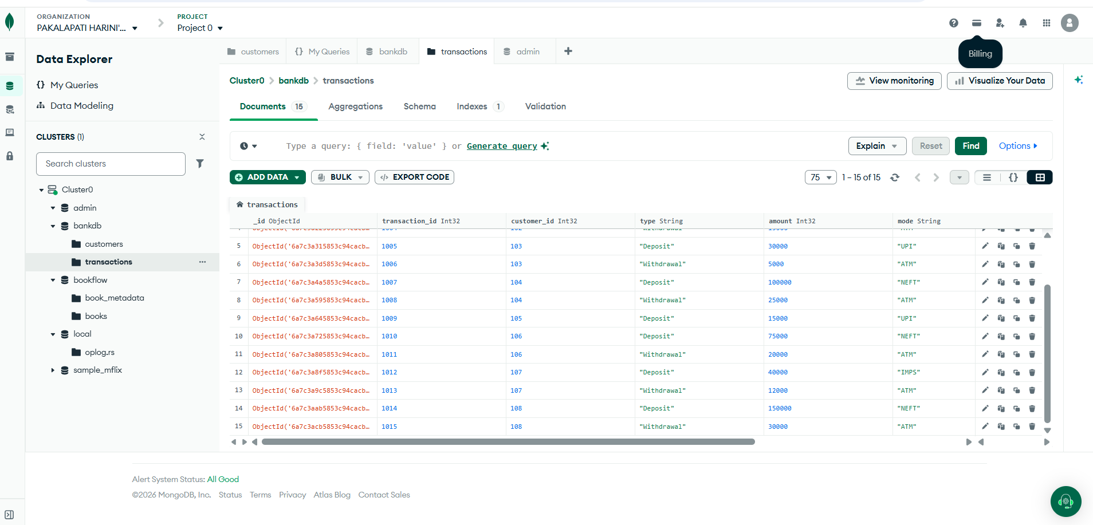
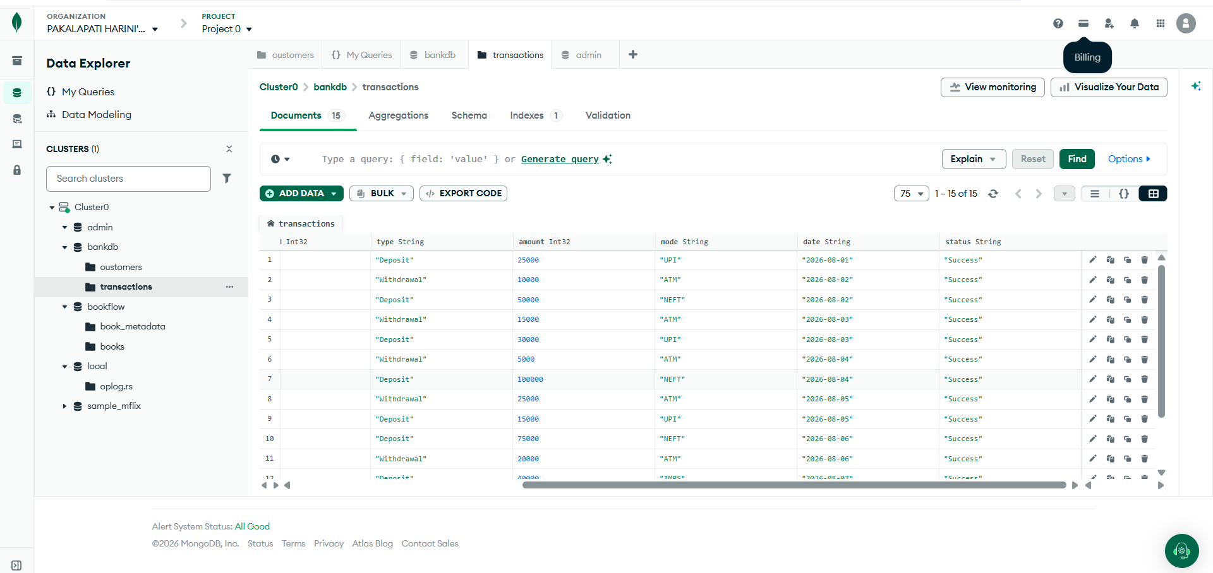
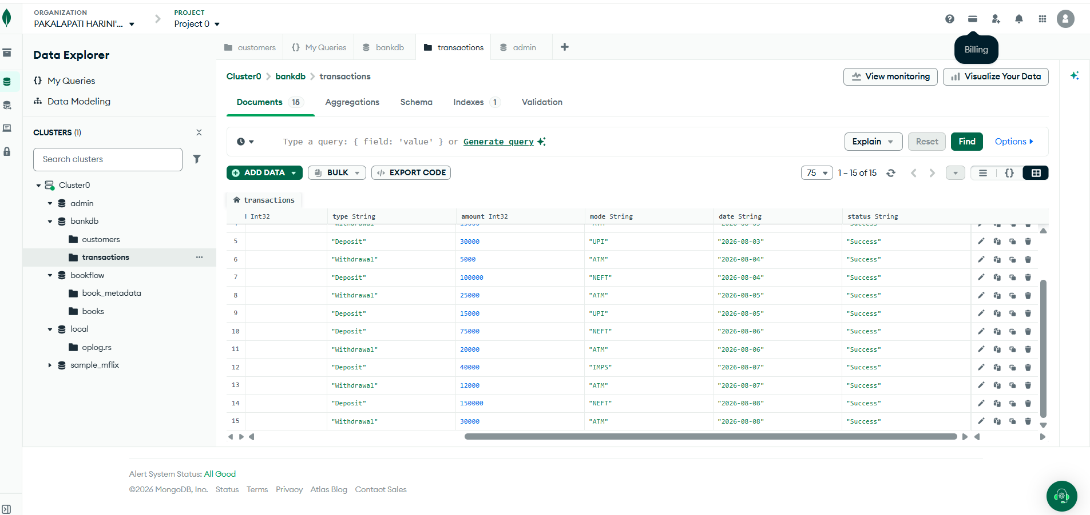

QUERY 1: DISPLAY ALL CUSTOMERS:
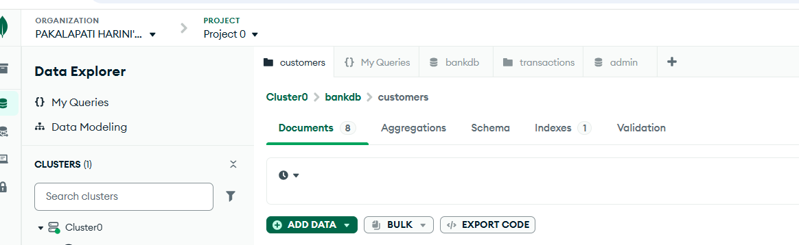
Output:
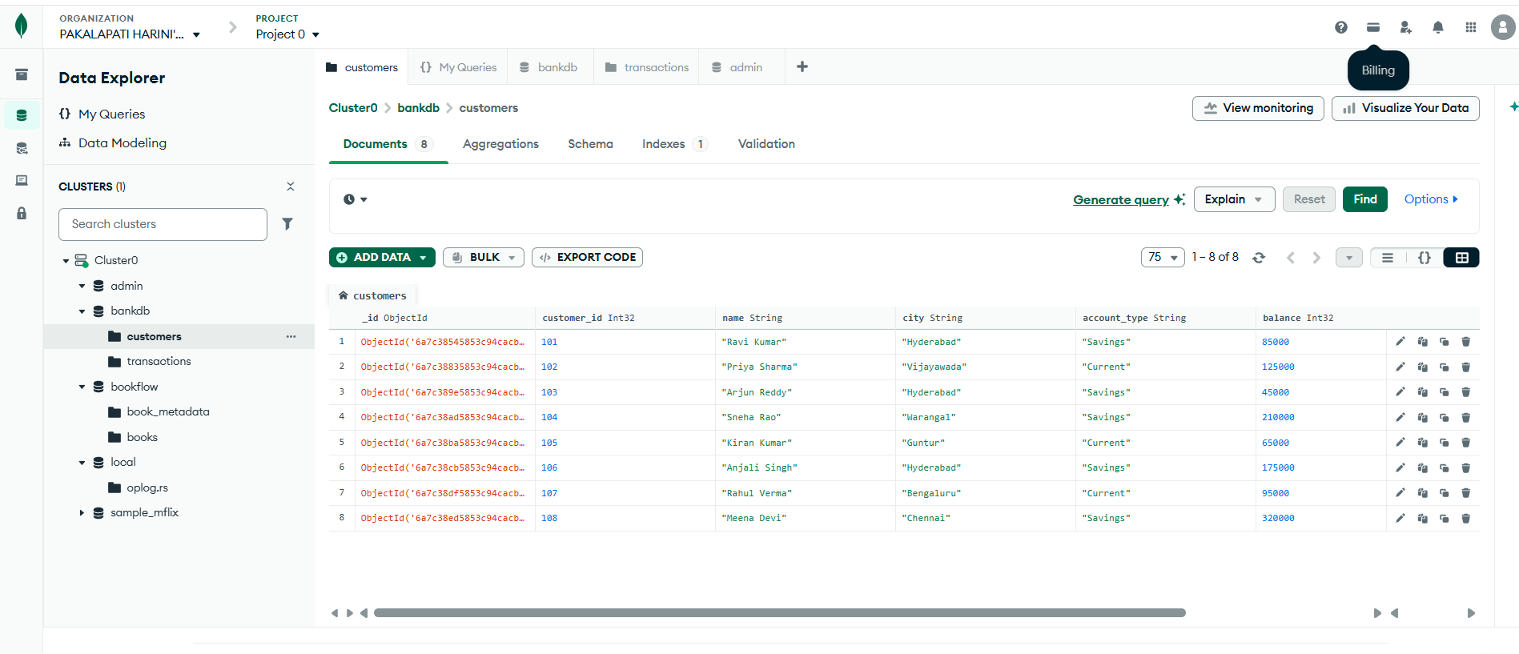

QUERY 2: FIND ACTIVE CUSTOMERS
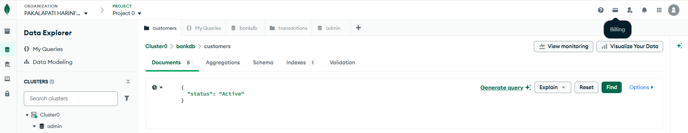
Output:
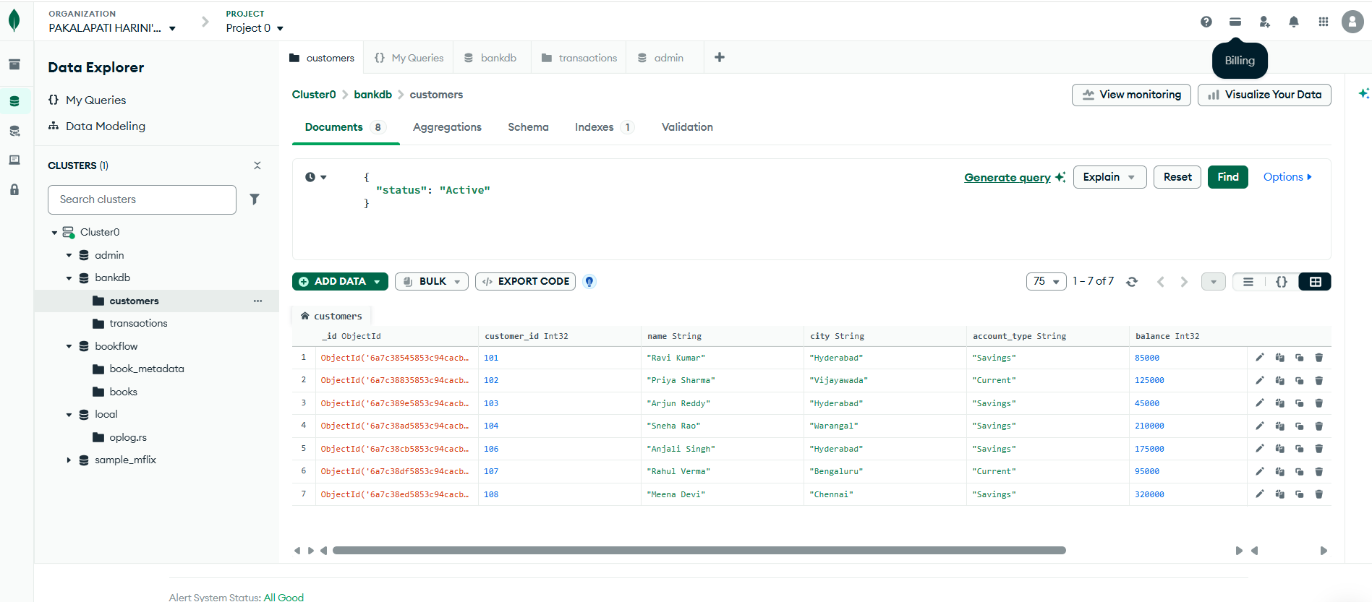
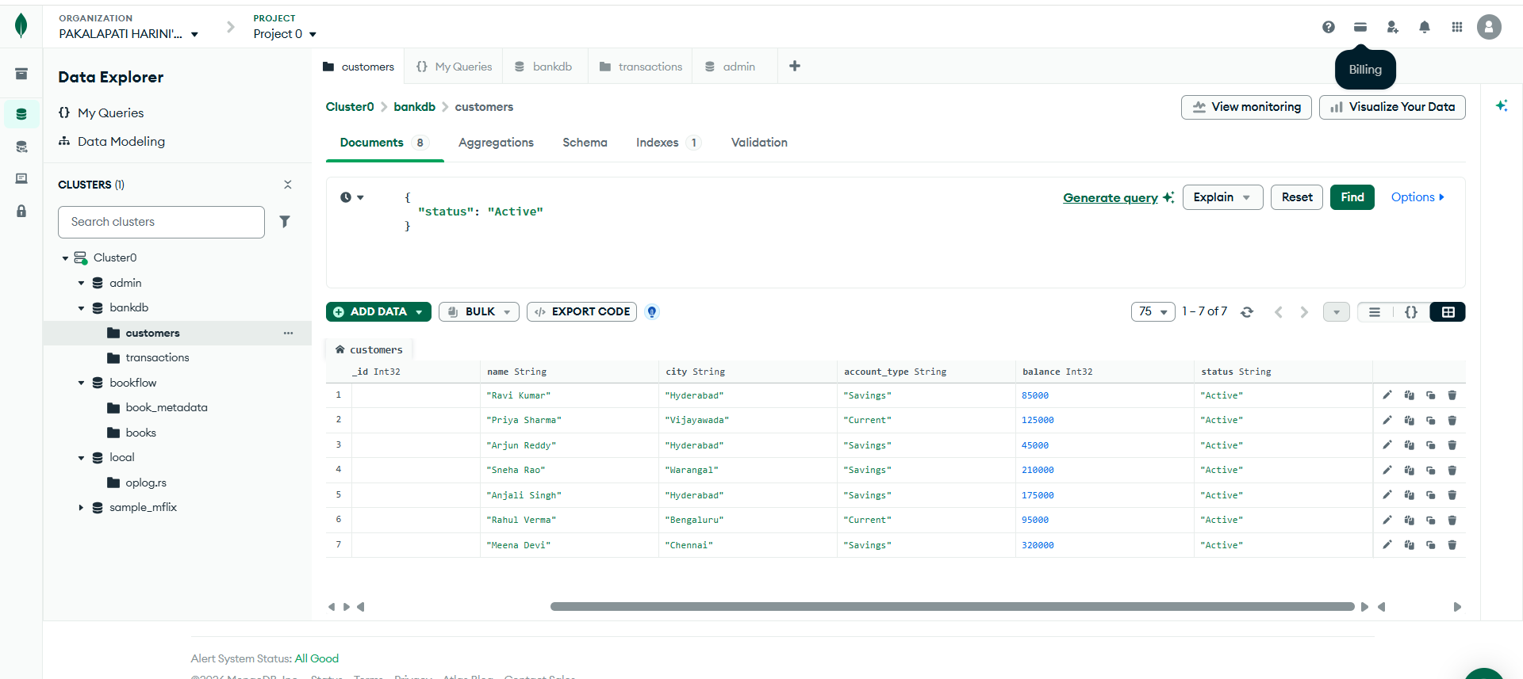
QUERY 3: FIND CUSTOMERS WITH BALANCE GREATER THAN 100000
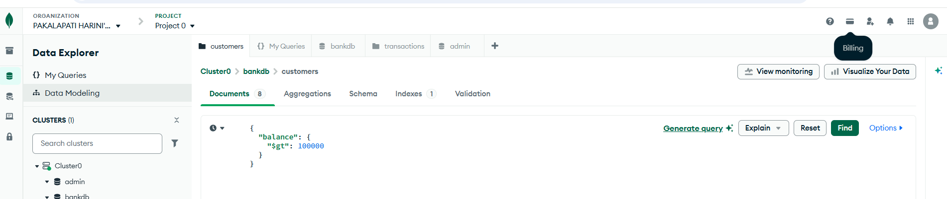

Output:
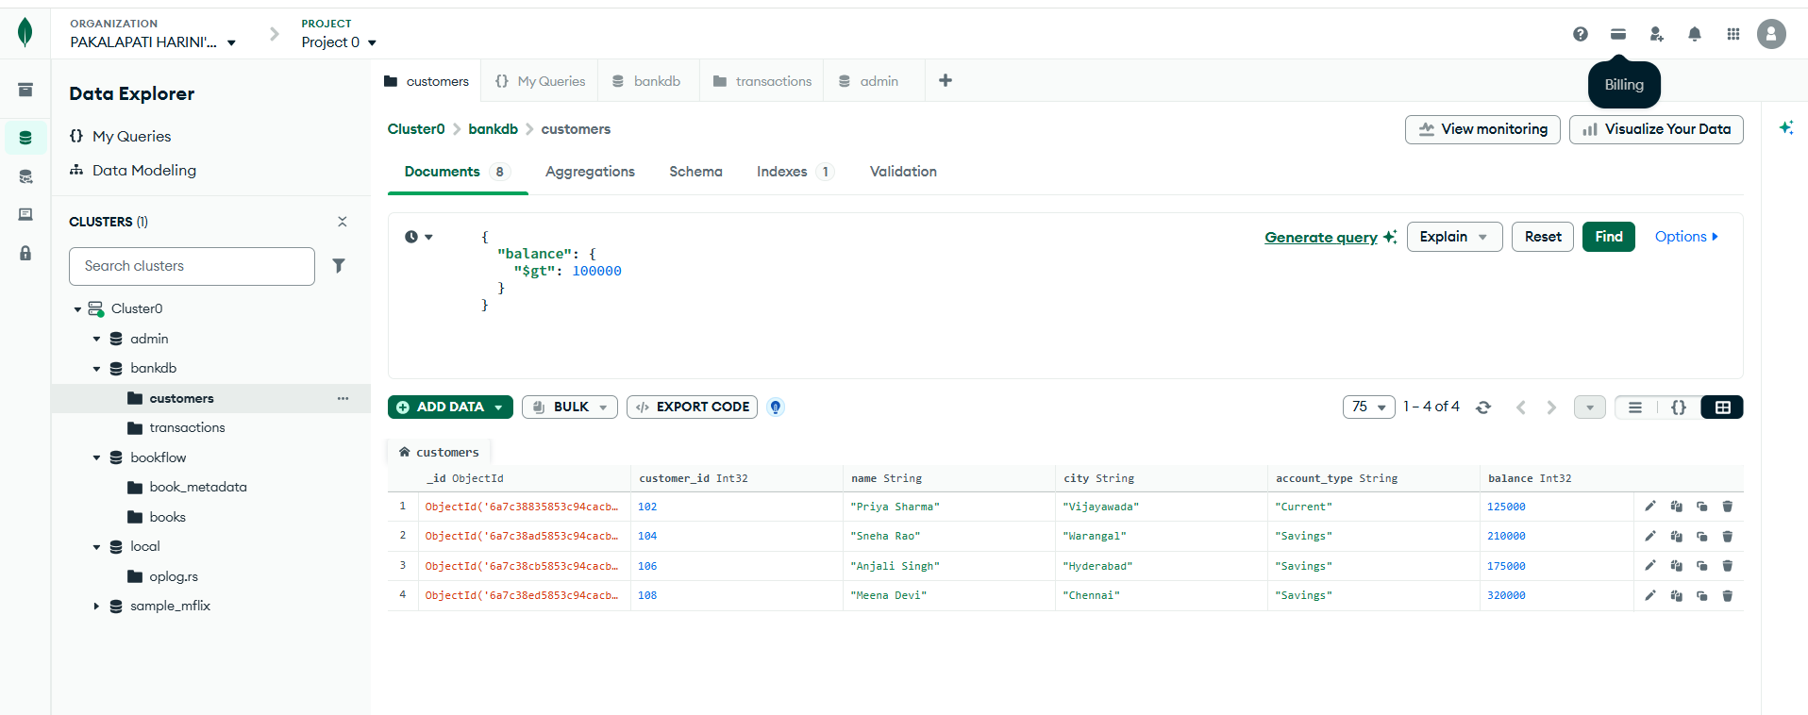

QUERY 4: FIND HYDERABAD CUSTOMERS:
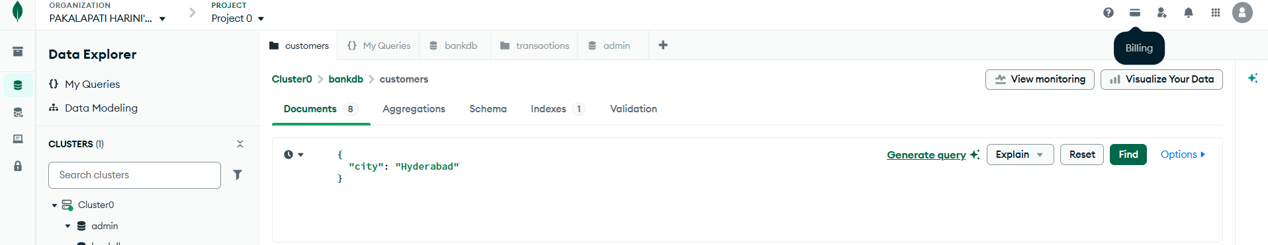
Output:
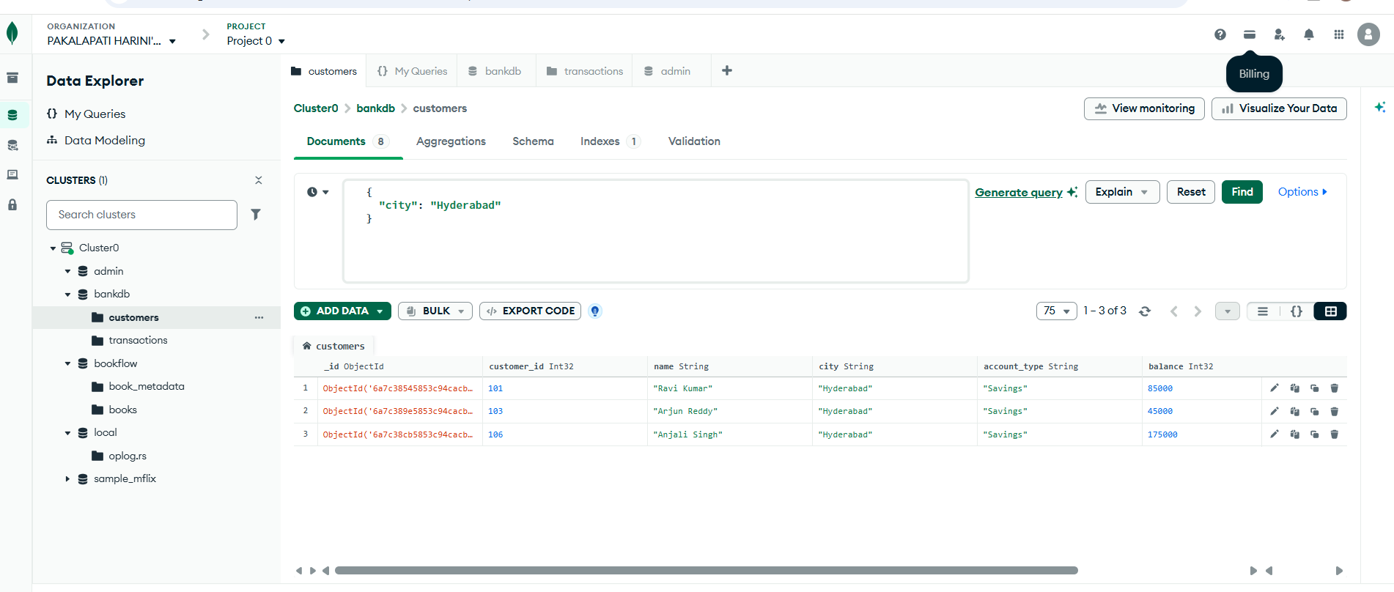
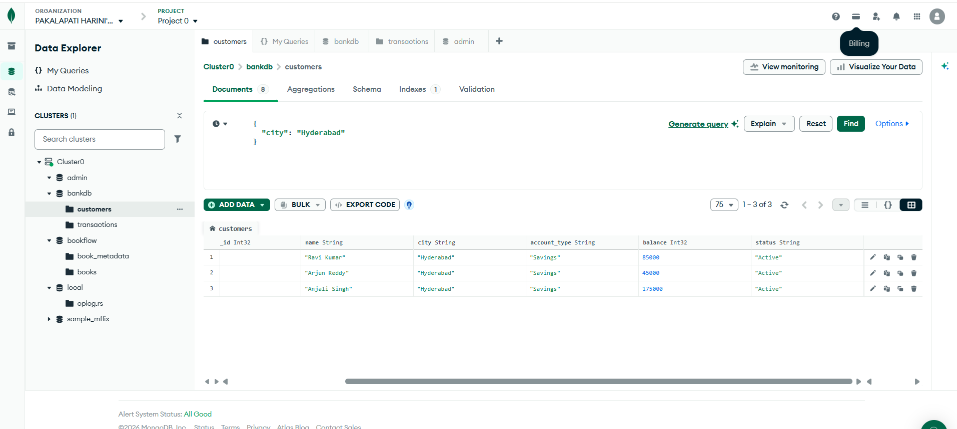

QUERY 5: FIND SAVINGS ACCOUNT CUSTOMERS:
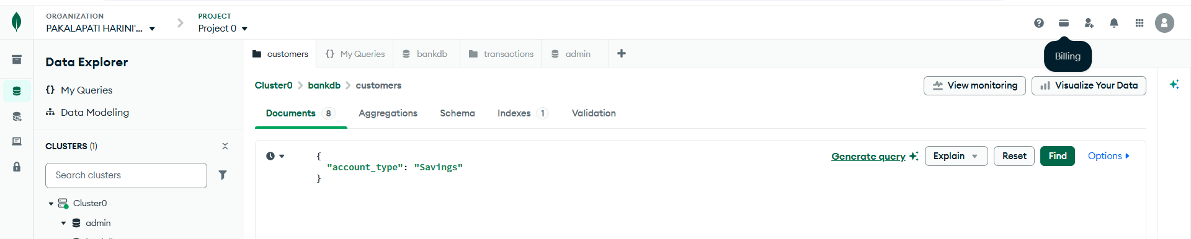
Output:
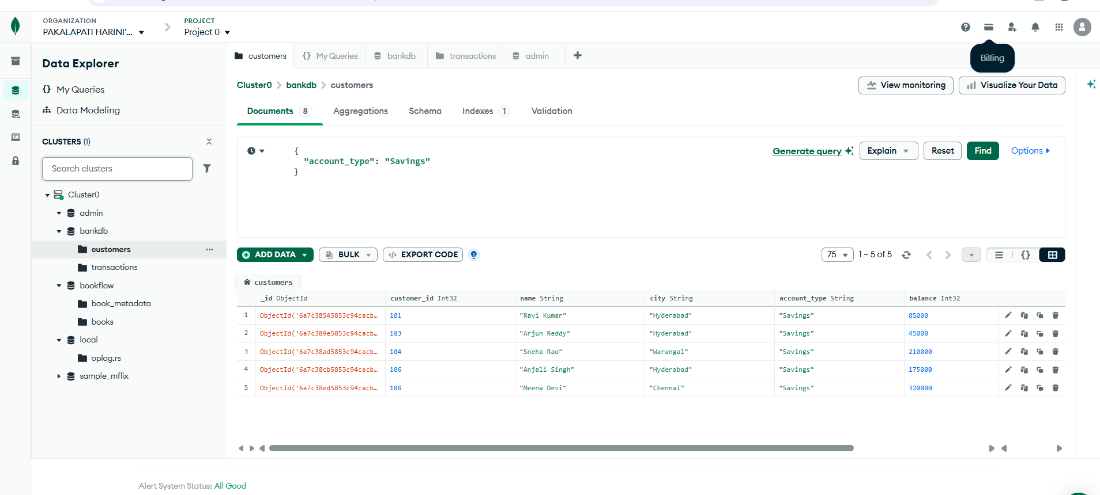

QUERY 6: FIND TRANSACTIONS GREATER THAN 20000:
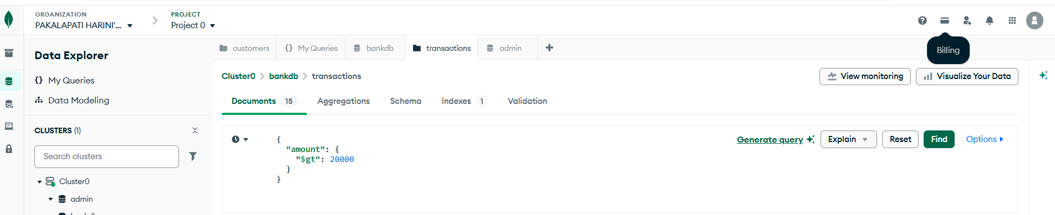
Output:
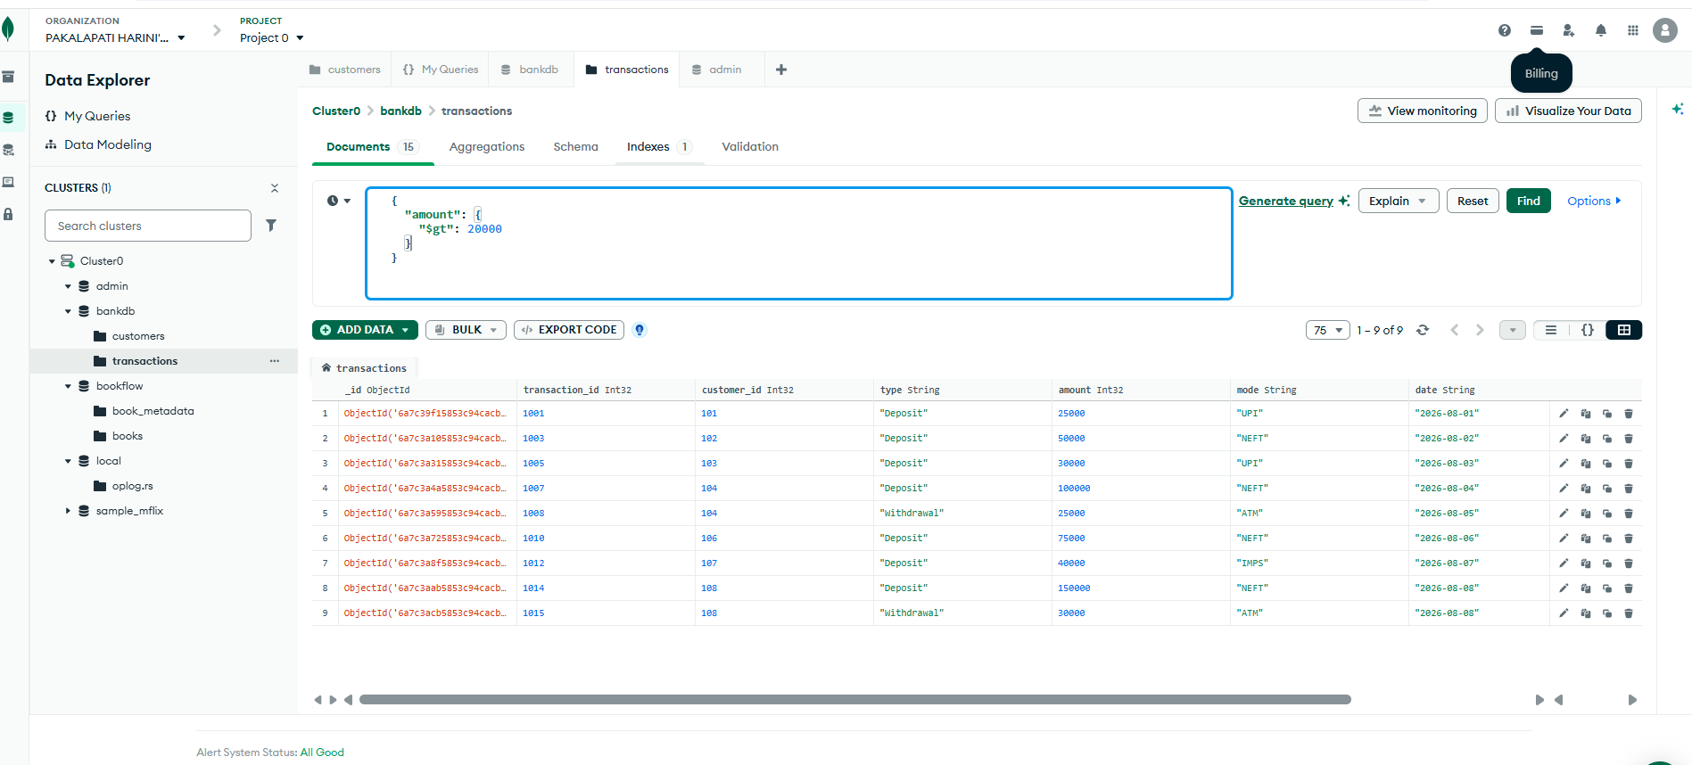
QUERY 7: FIND DEPOSITS
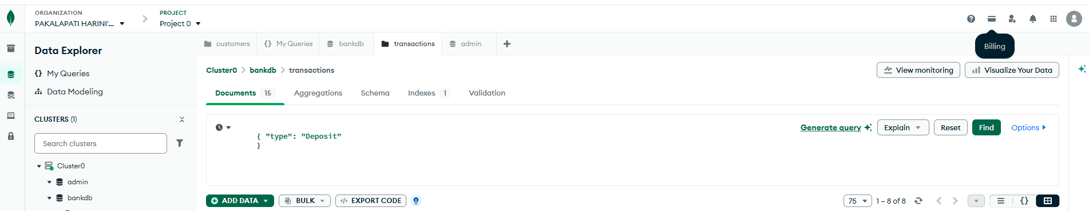
Output:
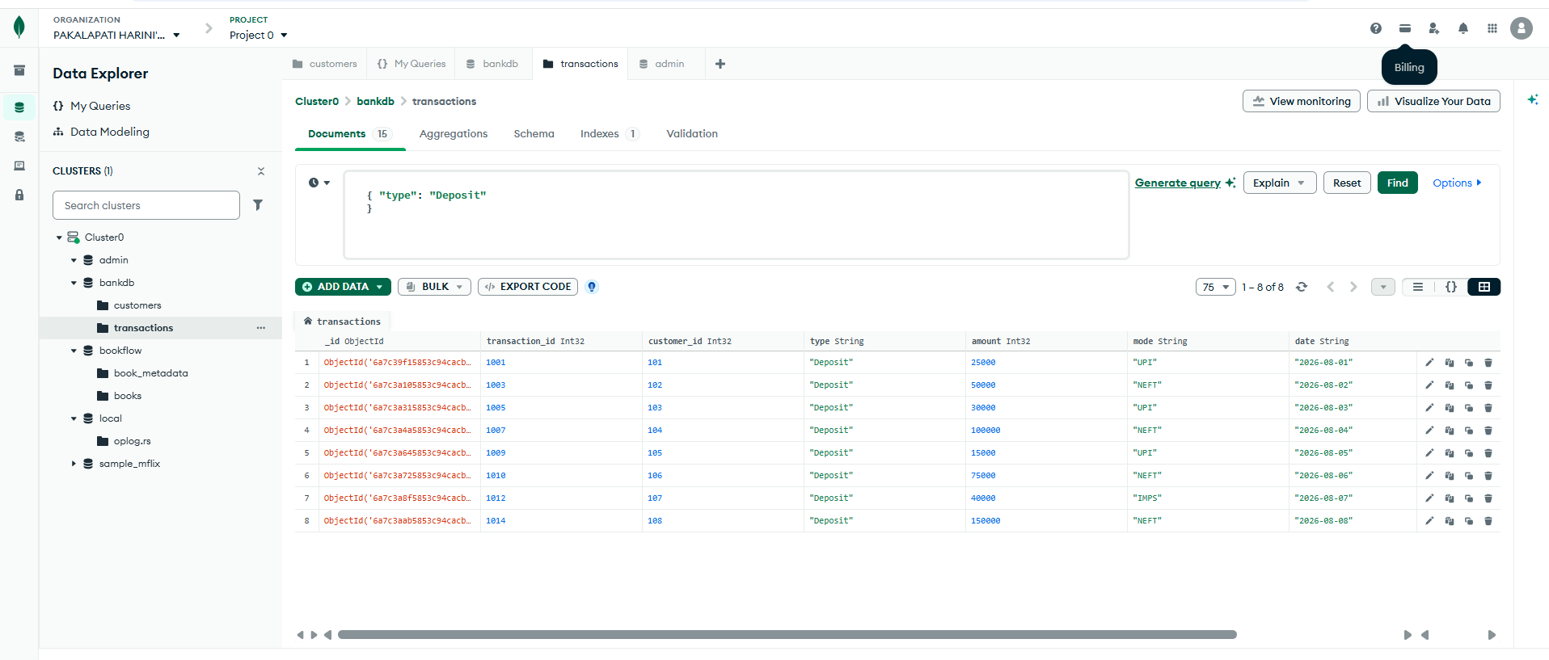

QUERY 8: FIND ATM TRANSACTIONS
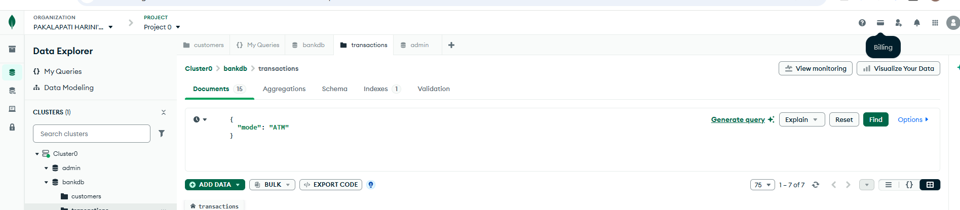
Output:
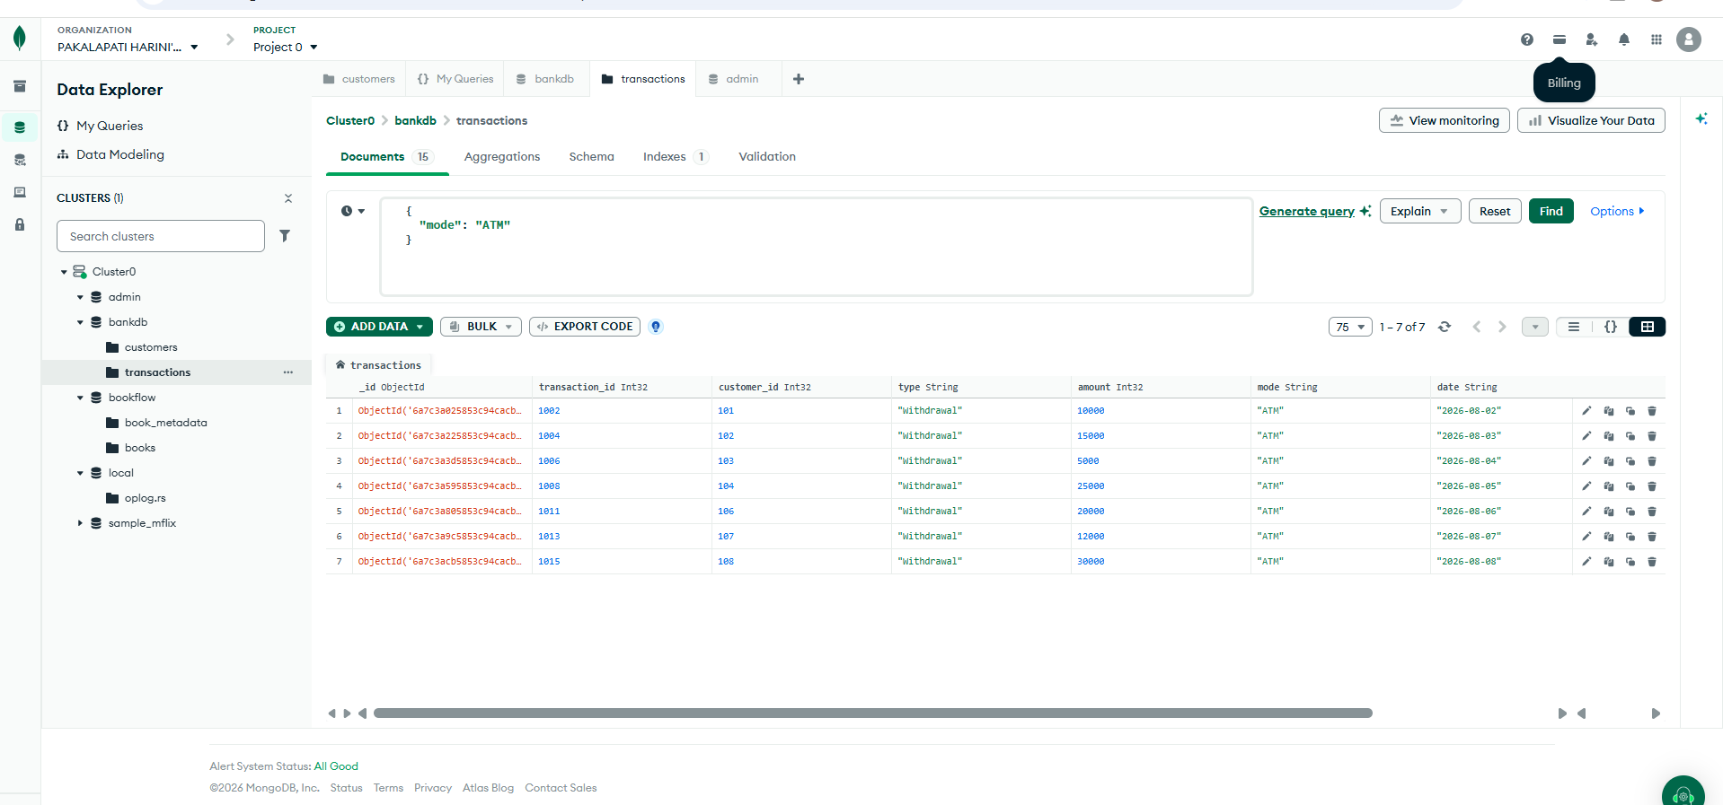
QUERY 9: FIND DEPOSITS GREATER THAN 50000
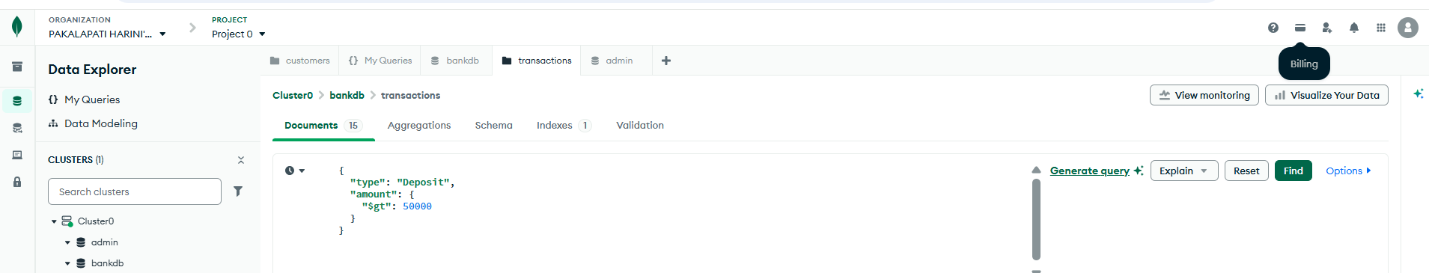
Output:
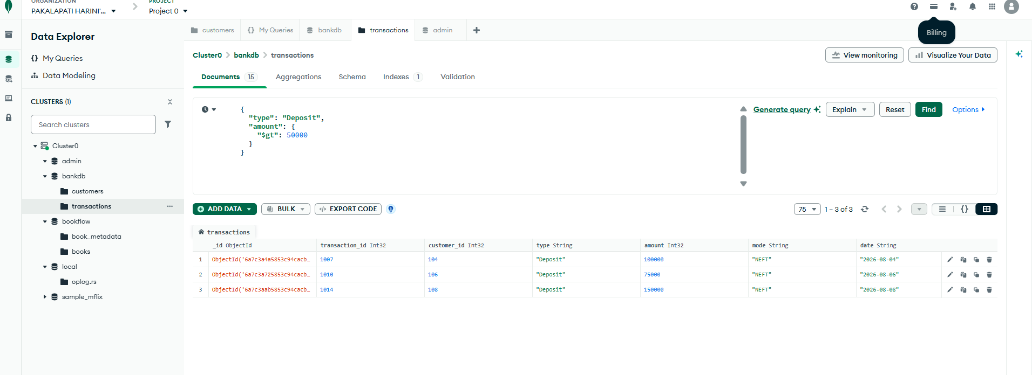

QUERY 10: FIND HYDERABAD CUSTOMERS WITH HIGH BALANCE

Output:
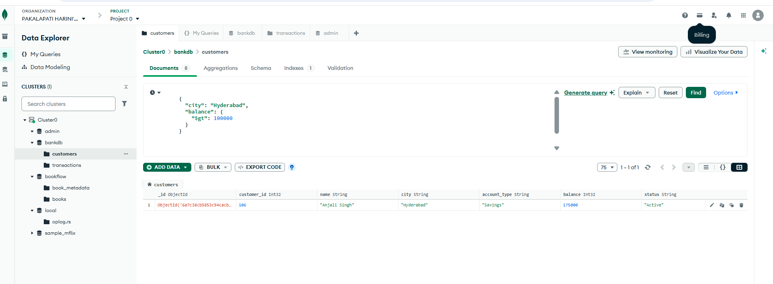

QUERY 11: FIND CUSTOMERS IN MULTIPLE CITIES

Output:
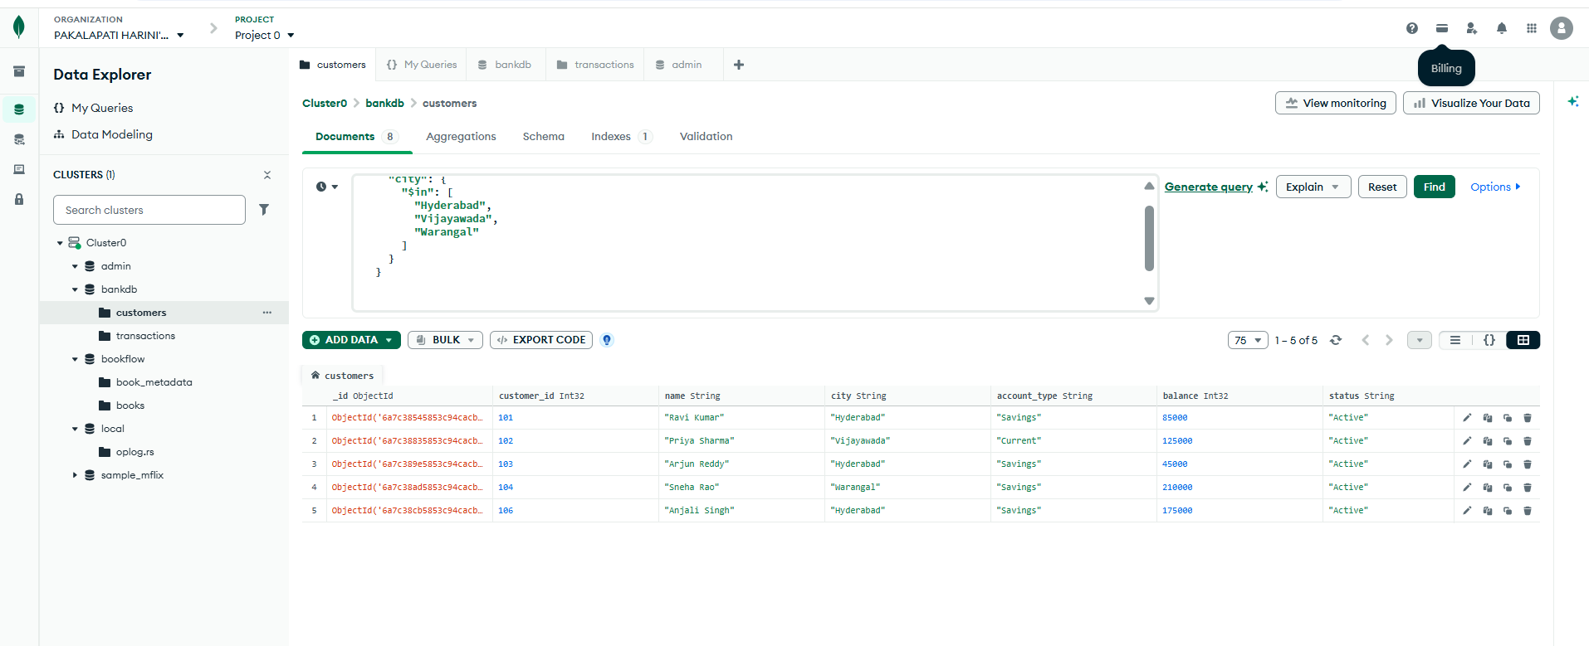

QUERY 12: SORT CUSTOMERS BY BALANCE
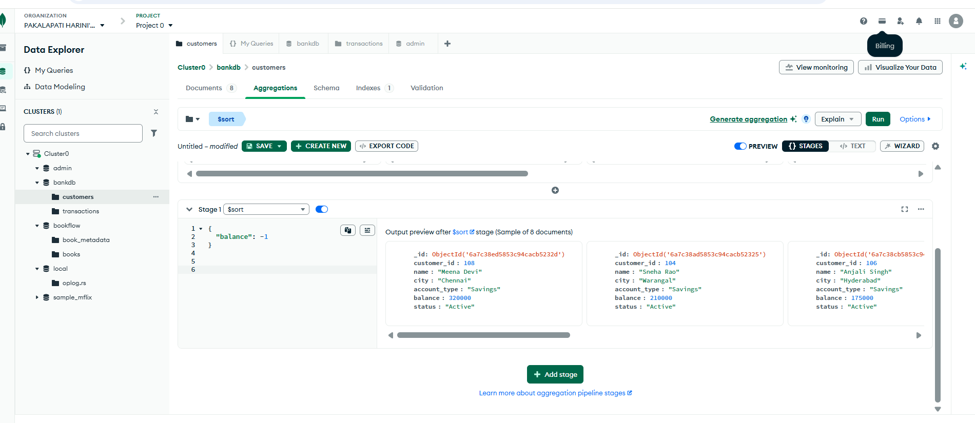
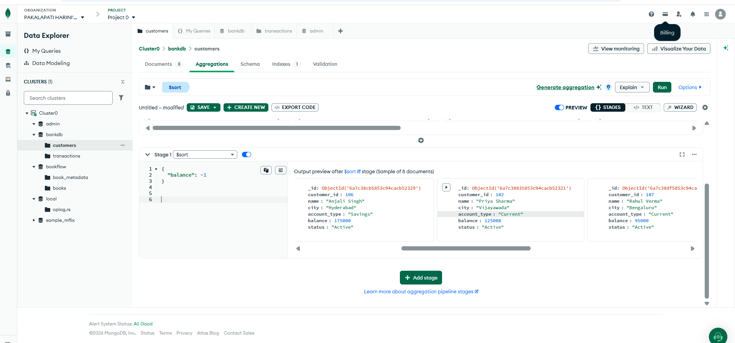
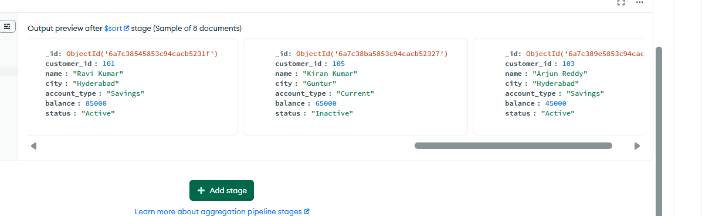

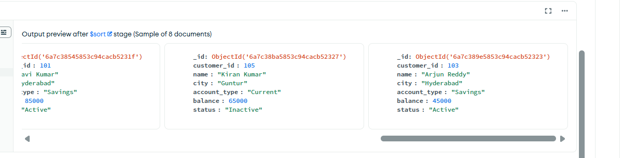

QUERY 13: CALCULATE TOTAL TRANSACTION AMOUNT

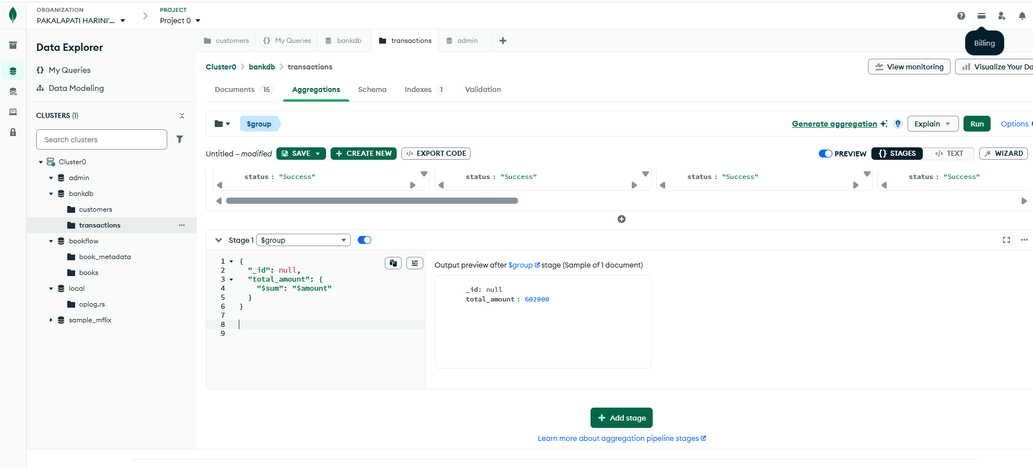
QUERY 14: CALCULATE AVERAGE TRANSACTION AMOUNT
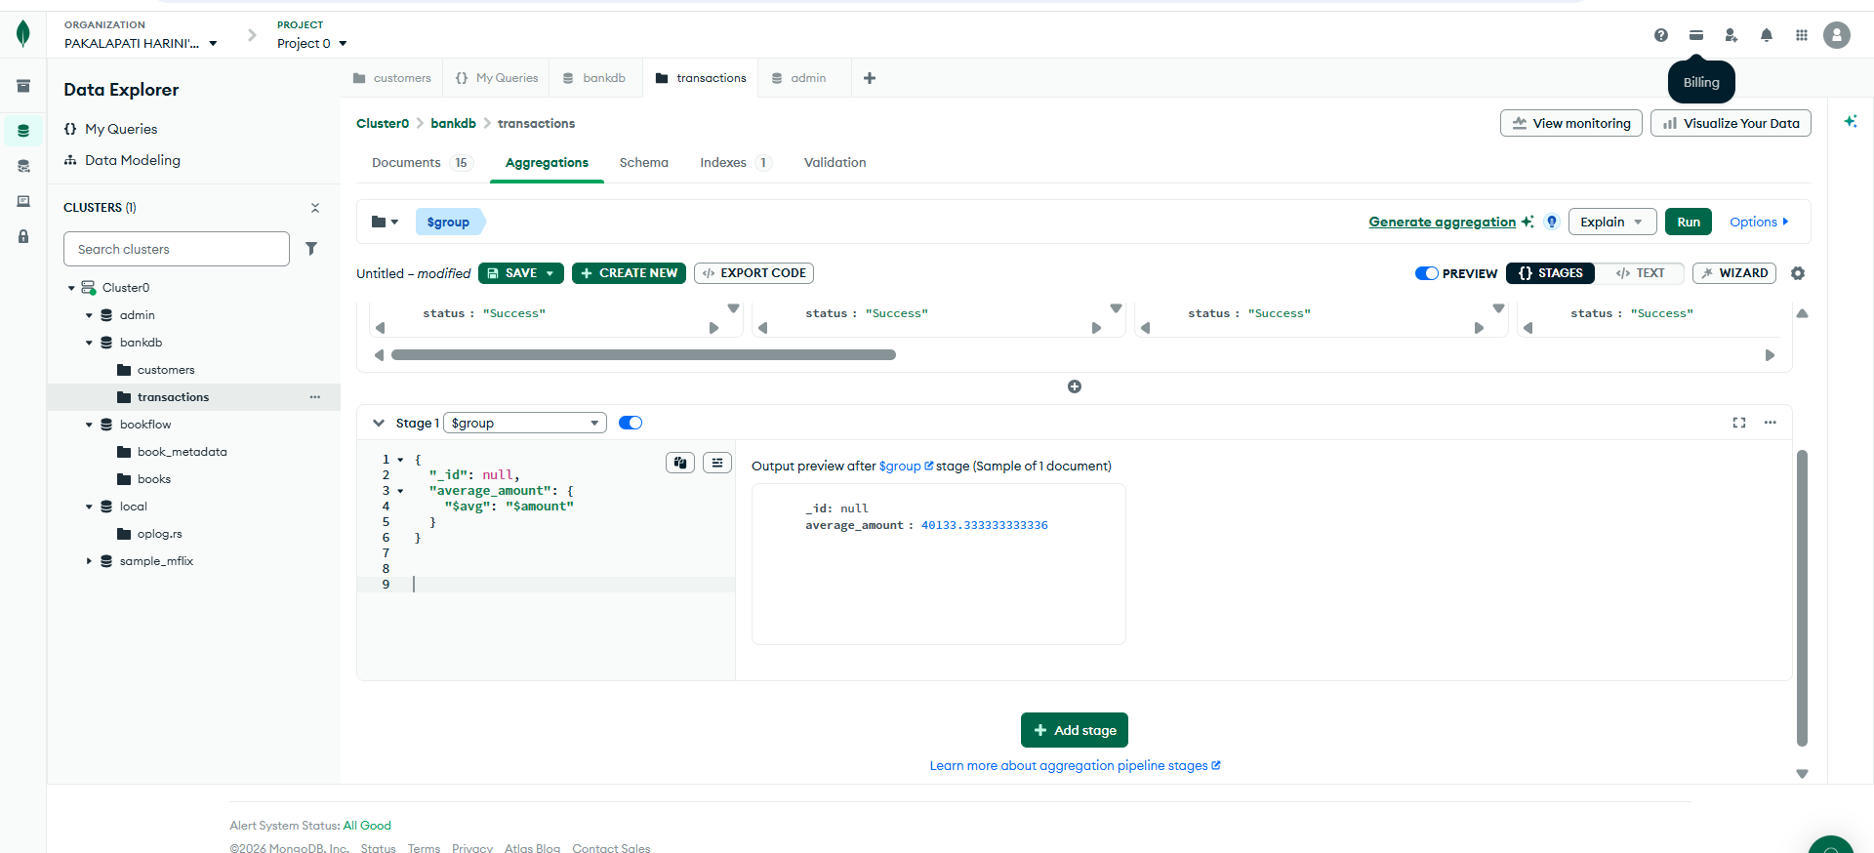

QUERY 15: TOTAL TRANSACTION AMOUNT BY TYPE
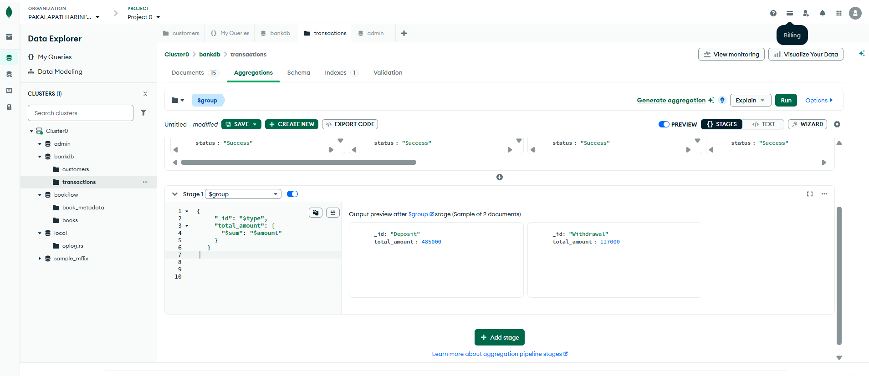

QUERY 16: NUMBER OF TRANSACTIONS PER CUSTOMER
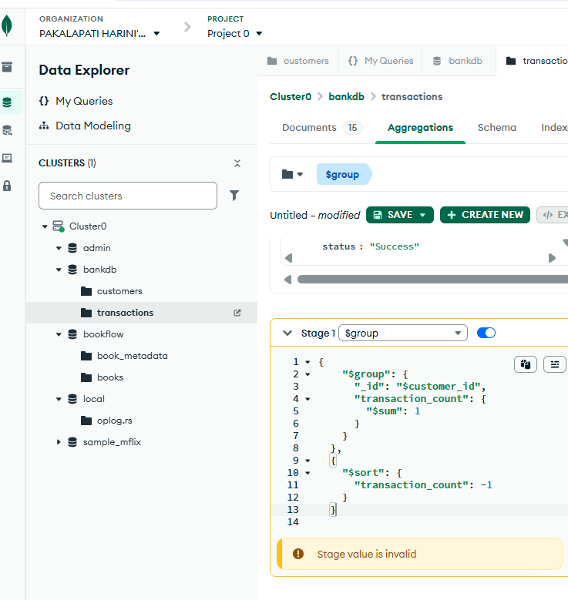

QUERY 17: CUSTOMER + TRANSACTION JOI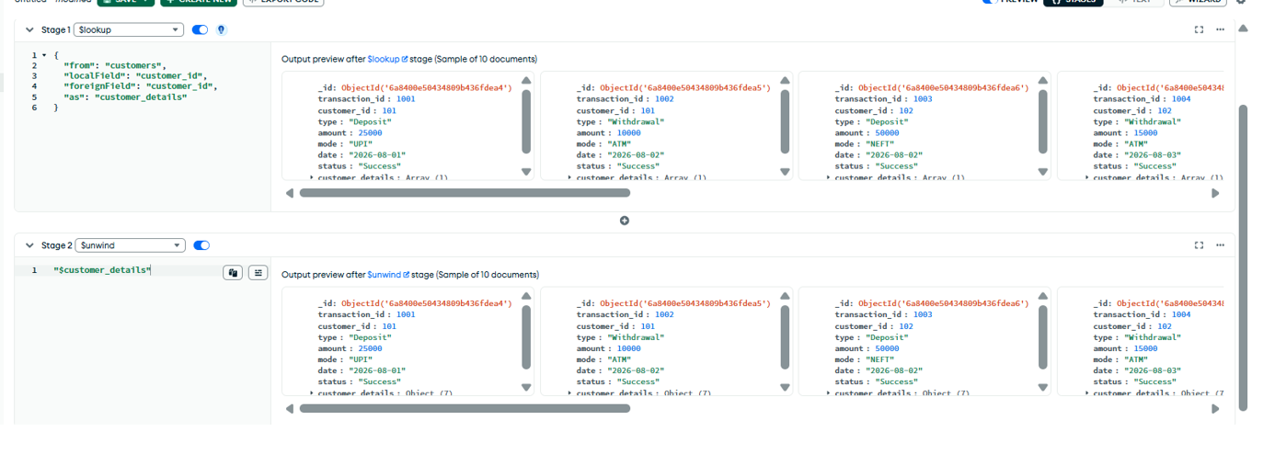

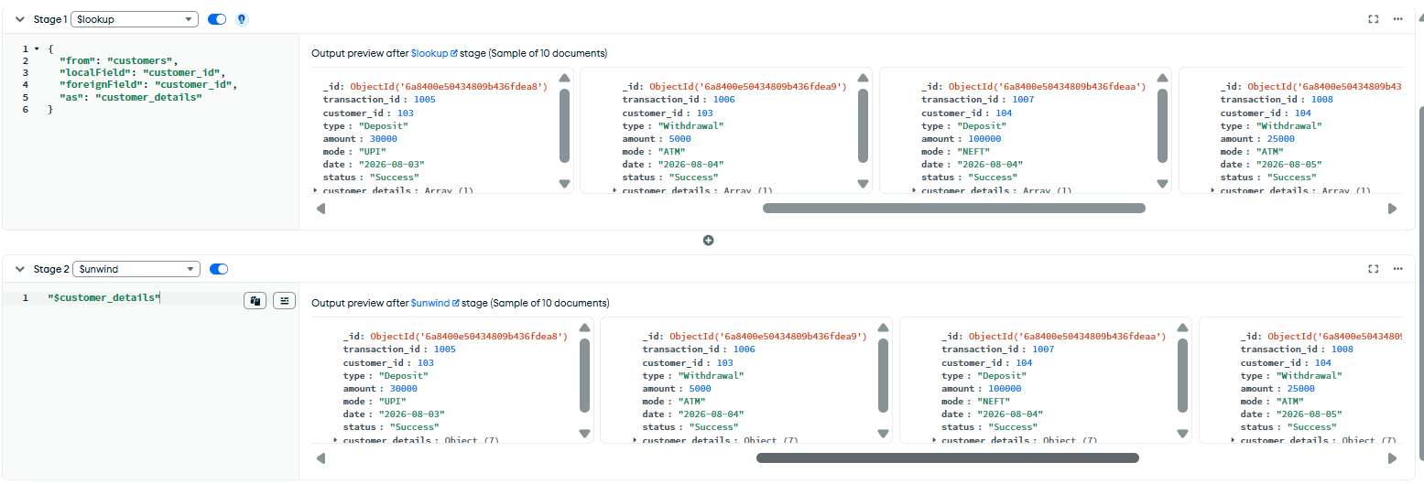
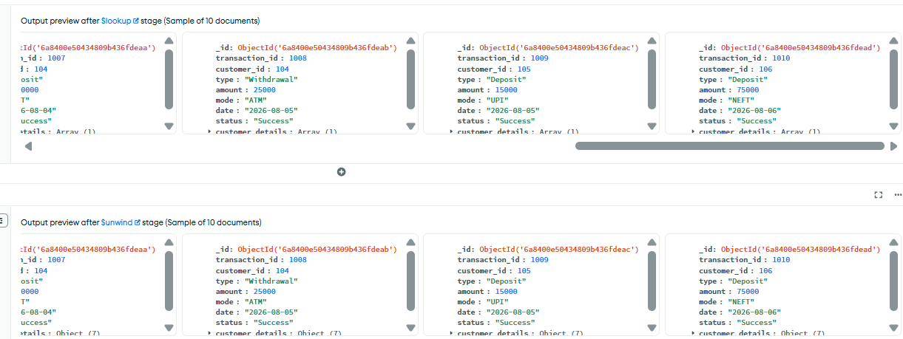

QUERY 18: DISPLAY CUSTOMER NAME AND TRANSACTION AMOUNT
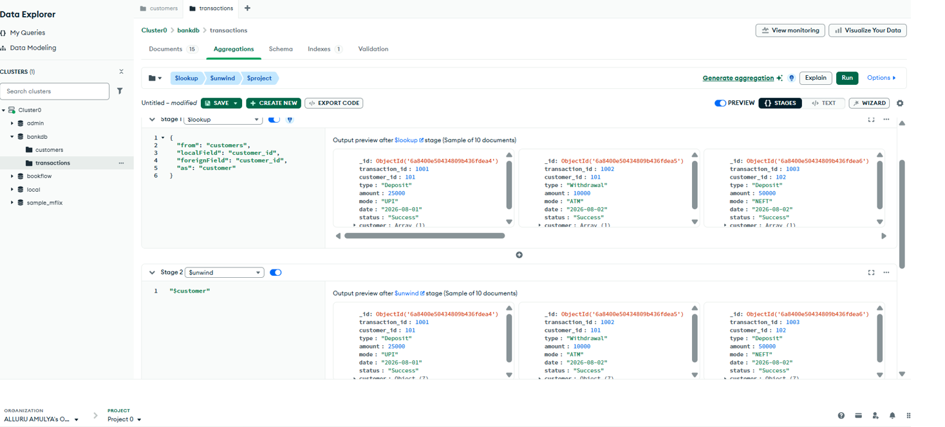
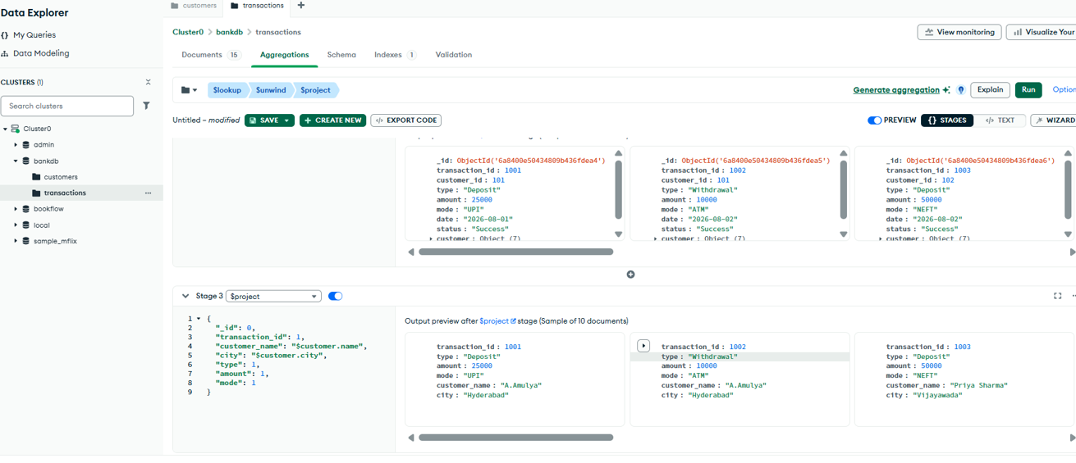

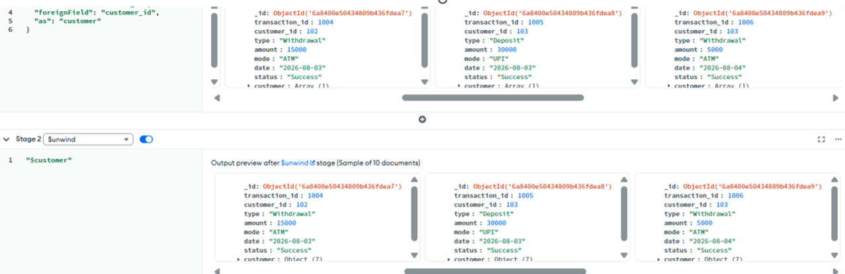

QUERY 19: TOTAL TRANSACTION AMOUNT FOR EACH CUSTOMER
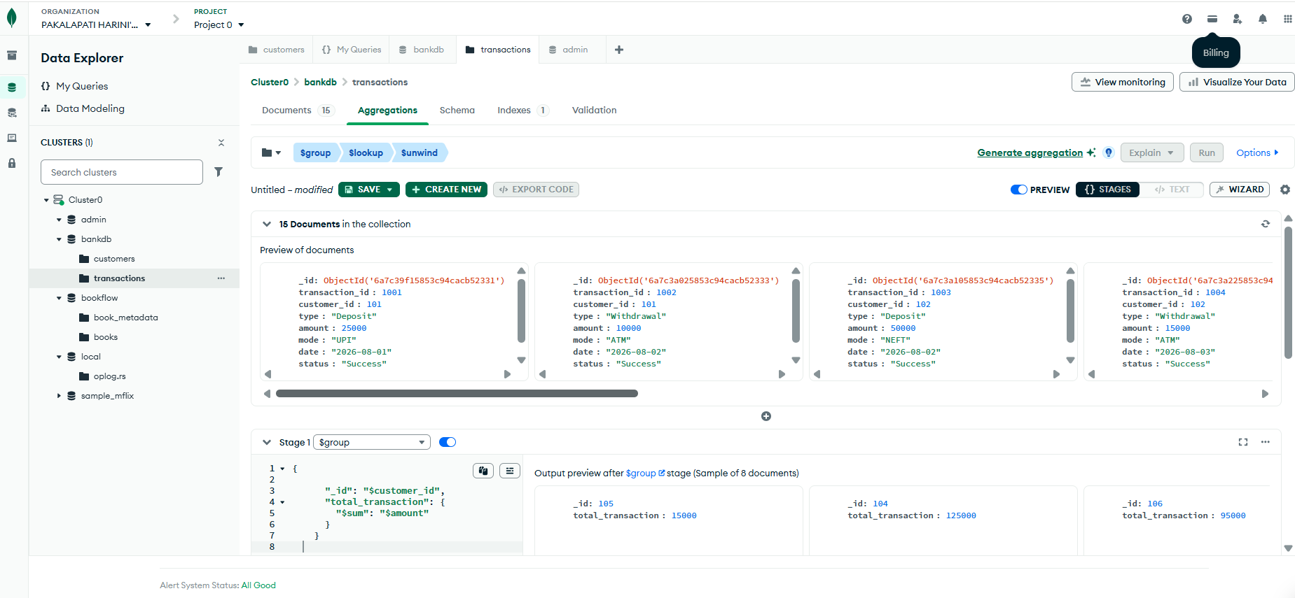
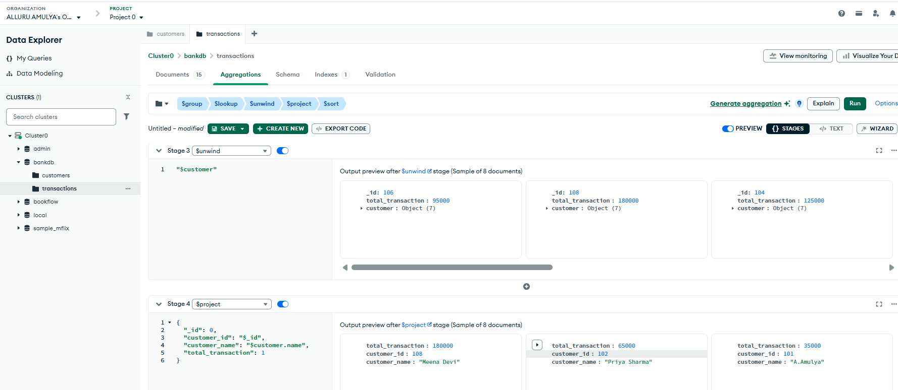
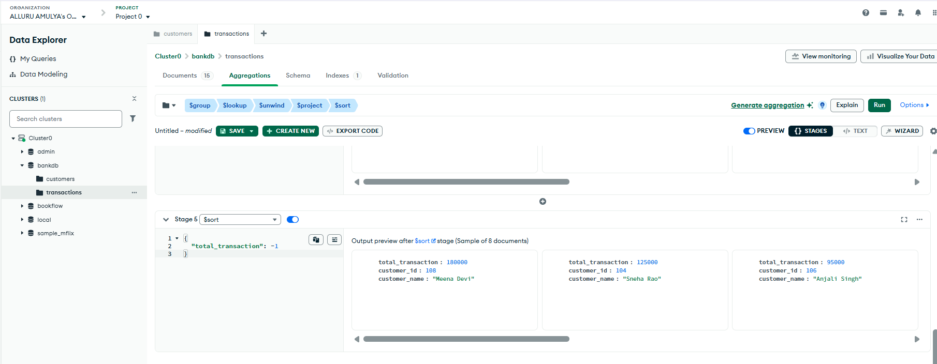
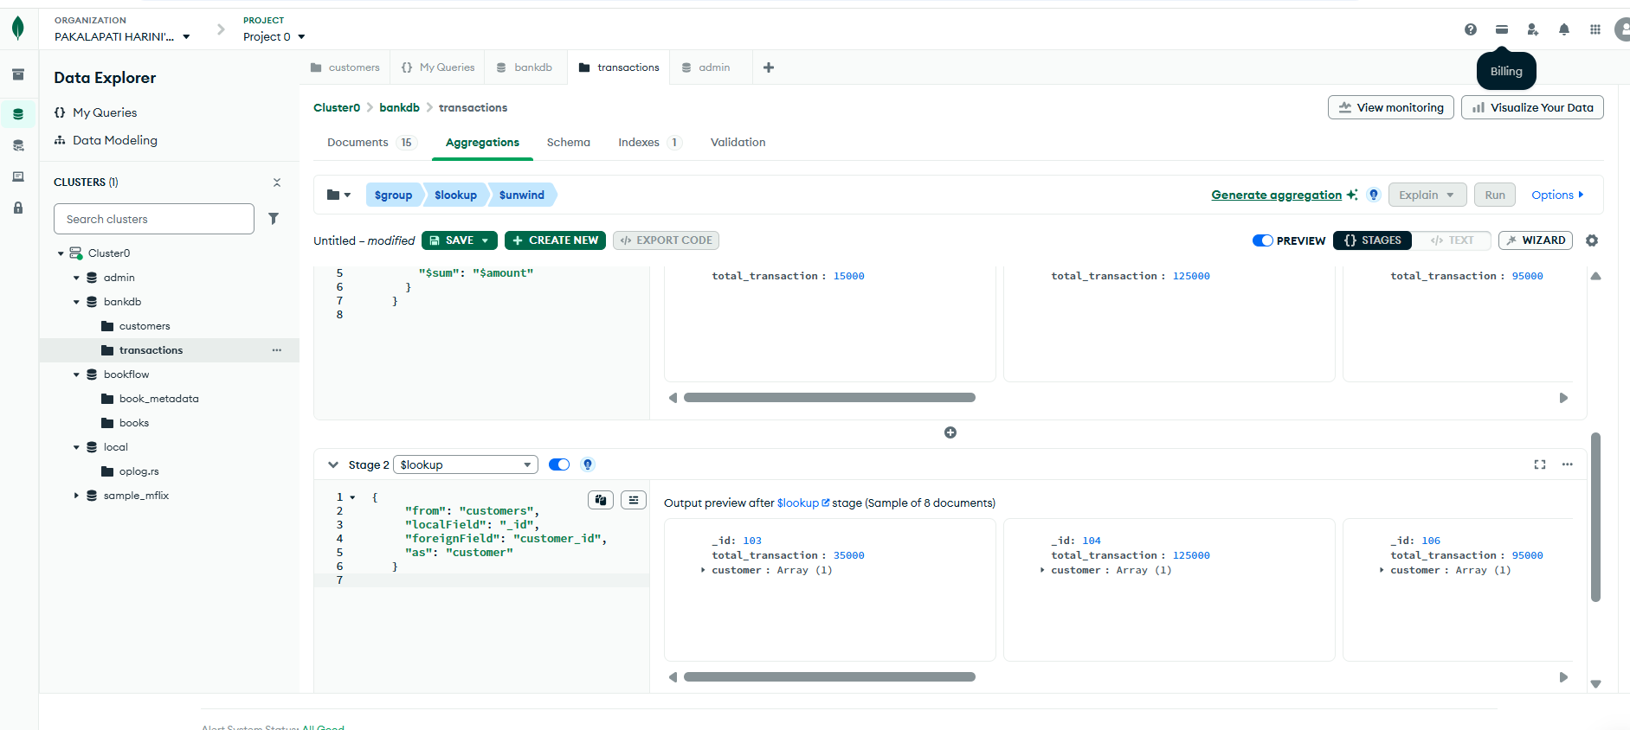
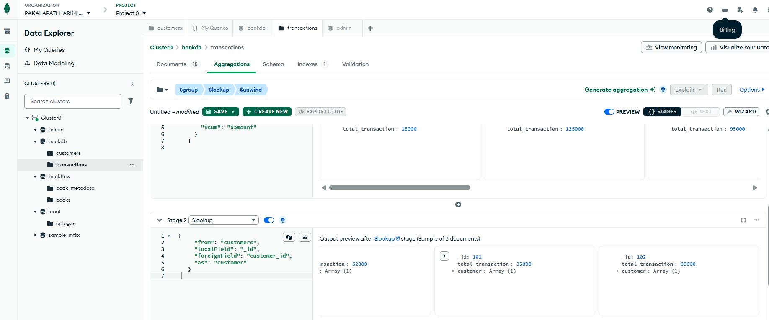
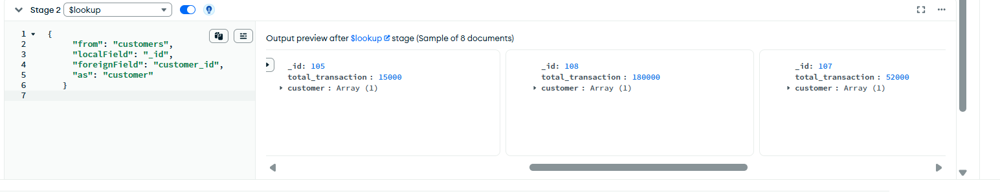
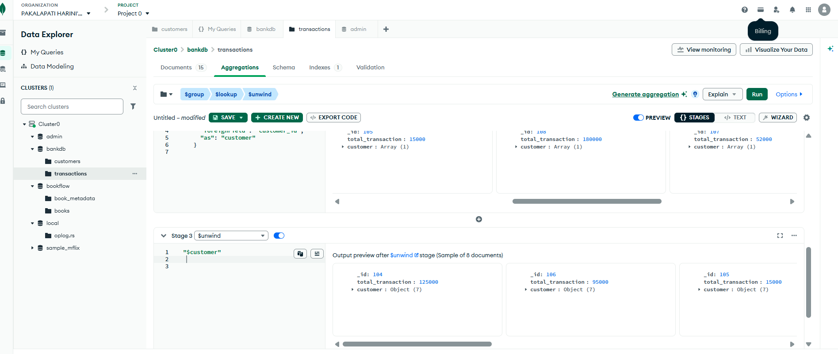
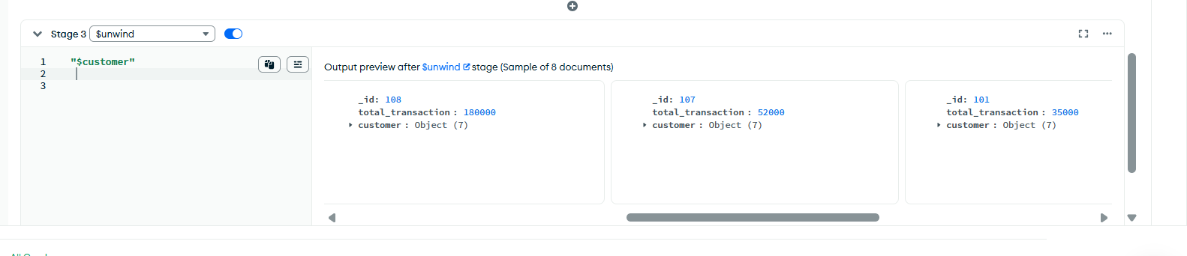
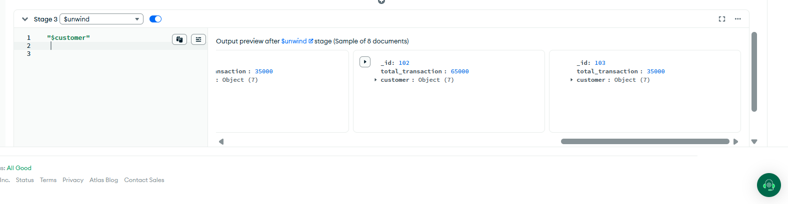

QUERY 20: COMPLEX BANK TRANSACTION REPORT
